Name: S.Swetha

Roll.no:22CSEA28

AIM

To draw flowchart and write algorithm, program to exchange two values using third

variable.

Algorithm:

|  |  |
| --- | --- |
| Step 1 | • Start |
| Step 2 | : read values of a and b |
| Step 3 | : assign c=a |
| Step 4 | . assign a=b |
| Step 5 | . assign b=c |
| Step 6 | display a, b |
| step 7 | • Stop |

Program:

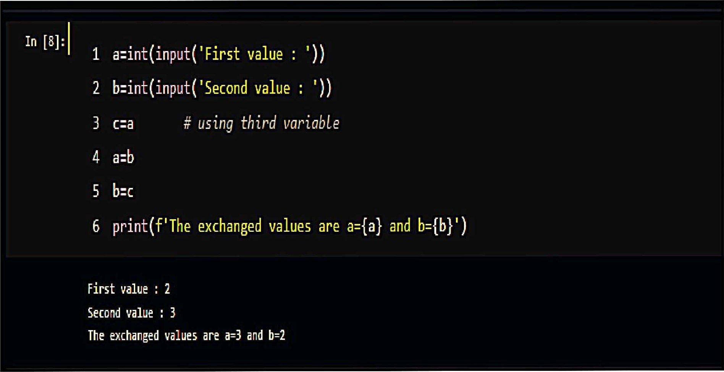



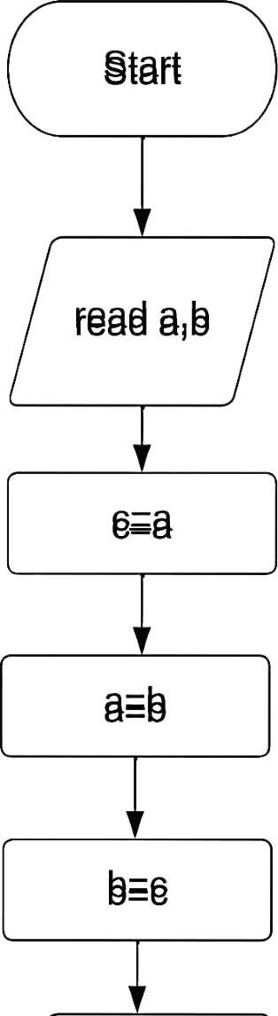

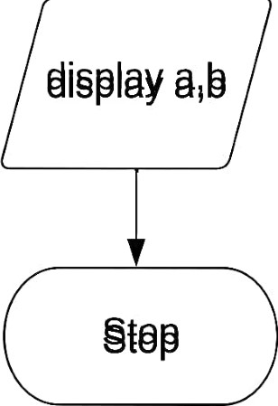

Result: : 2(b) COMMA OPERATOR



To draw flowchart and write algorithm, program to exchange two values using comma operator.

Algorithm:

|  |  |
| --- | --- |
| Step 1 | : Start |
| Step 2 | . read values of x, y |
| Step 3 | . assign x, y=y, x |
| Step 4 | • display x, y |
| Step 5 | • Stop |

Program:

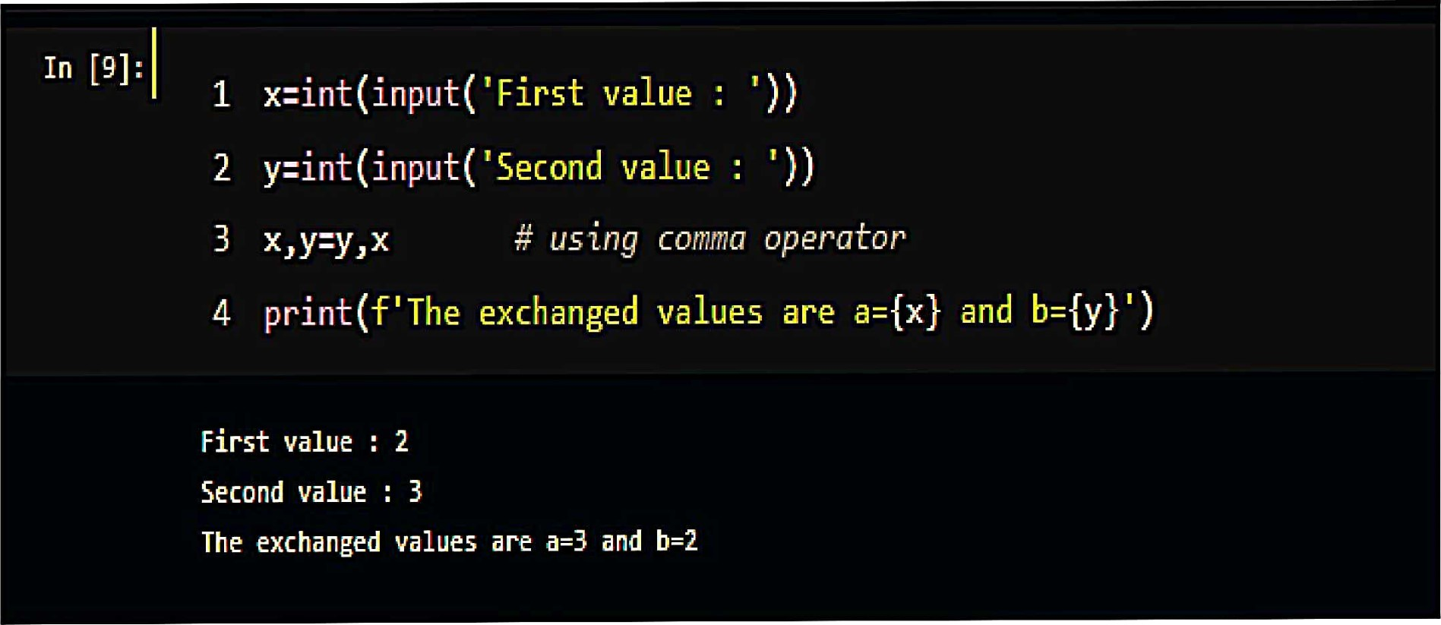



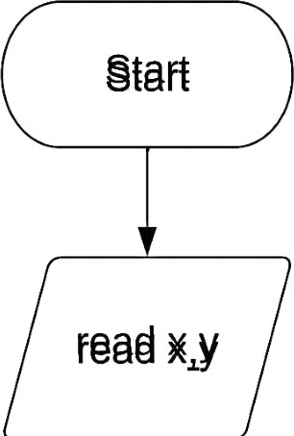

|  |  |
| --- | --- |
|  |  |
| *ay-yxk | |
|  |  |

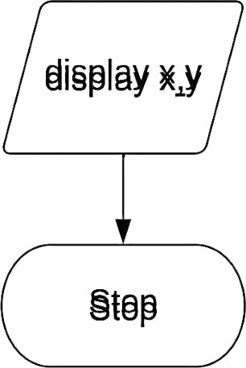

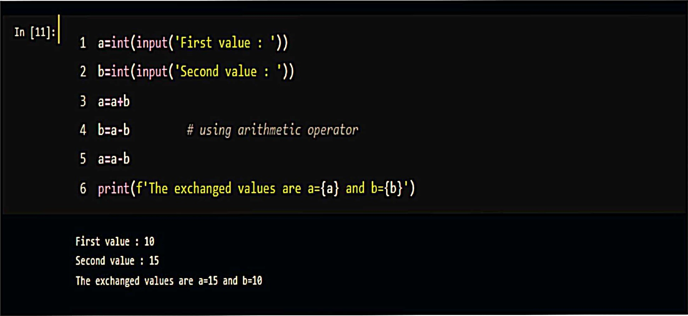 : 2(c) ARITHMETIC OPERATOR



To draw flowchart and write algorithm, program to exchange two values using arithmetic operator.

Algorithm:

Step 1 : Start

Step 2 : read values of a, b

Step 3 : compute a-a + b

Step 4 : compute b=a-b

Step 5 : compute a=a-b

Step 6 • display a, b

Step 7 • Stop

Program:

|  |  |
| --- | --- |
|  |  |
| a=a+b | |
|  |  |
| b=a-b | |
|  |  |
| a=a-b | |
|  |  |

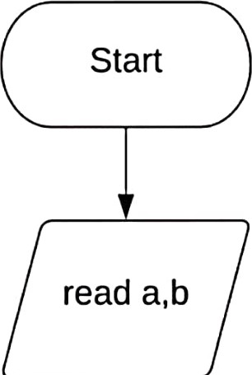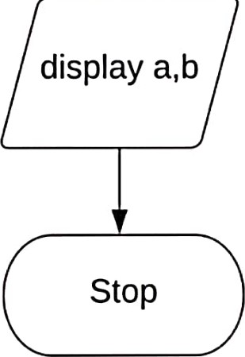

XOR OPERATOR

# : 25-12-2022



To draw flowchart and write algorithm, program to exchange two values using XOR operator.

Algorithm:

|  |  |
| --- | --- |
| Step 1 | : Start |
| Step 2 | . read values of a, b |
| Step 3 | : compute a=a  b |
| Step 4 | : compute b=a  b |
| Step 5 | : compute a-a  b |
| Step 6 | • display a, b |
| Step 7 | • Stop |

Program:



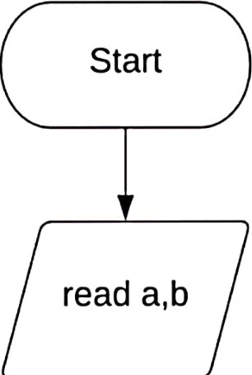

|  |  |
| --- | --- |
|  |  |
| a=aAb | |
|  |  |
| b=aAb | |
|  |  |
| a=aAb | |
|  |  |

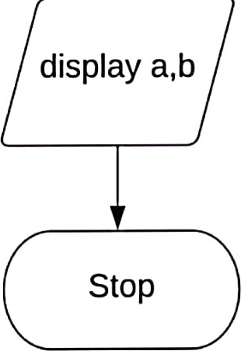

2(d) CIRCULATING LIST OF VALUES USING IN-BUILD FUNCTIONS

# 25-12-2022



draw flowchart and write algorithm, program to circulating the list of values usng in-build functions in python.

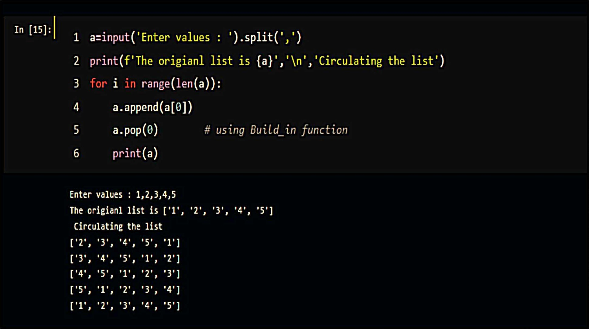Algorithm:

|  |  |
| --- | --- |
| Step 1 | • Start |
| Step 2 | : read list a |
| step 3 | display a |
| Step 4 | . assign i=0, n=size of a |
| Step 5 | : Check if i<n |
| Step 5.1 | If Yes, then a.append(a[O]), a.pop(O), i=i+l |
| step 5.2 | display a and go to step 5 |
| step 5.3 | • If No, then go to step 6 |
| Step 6 | • Stop |

Program:



No 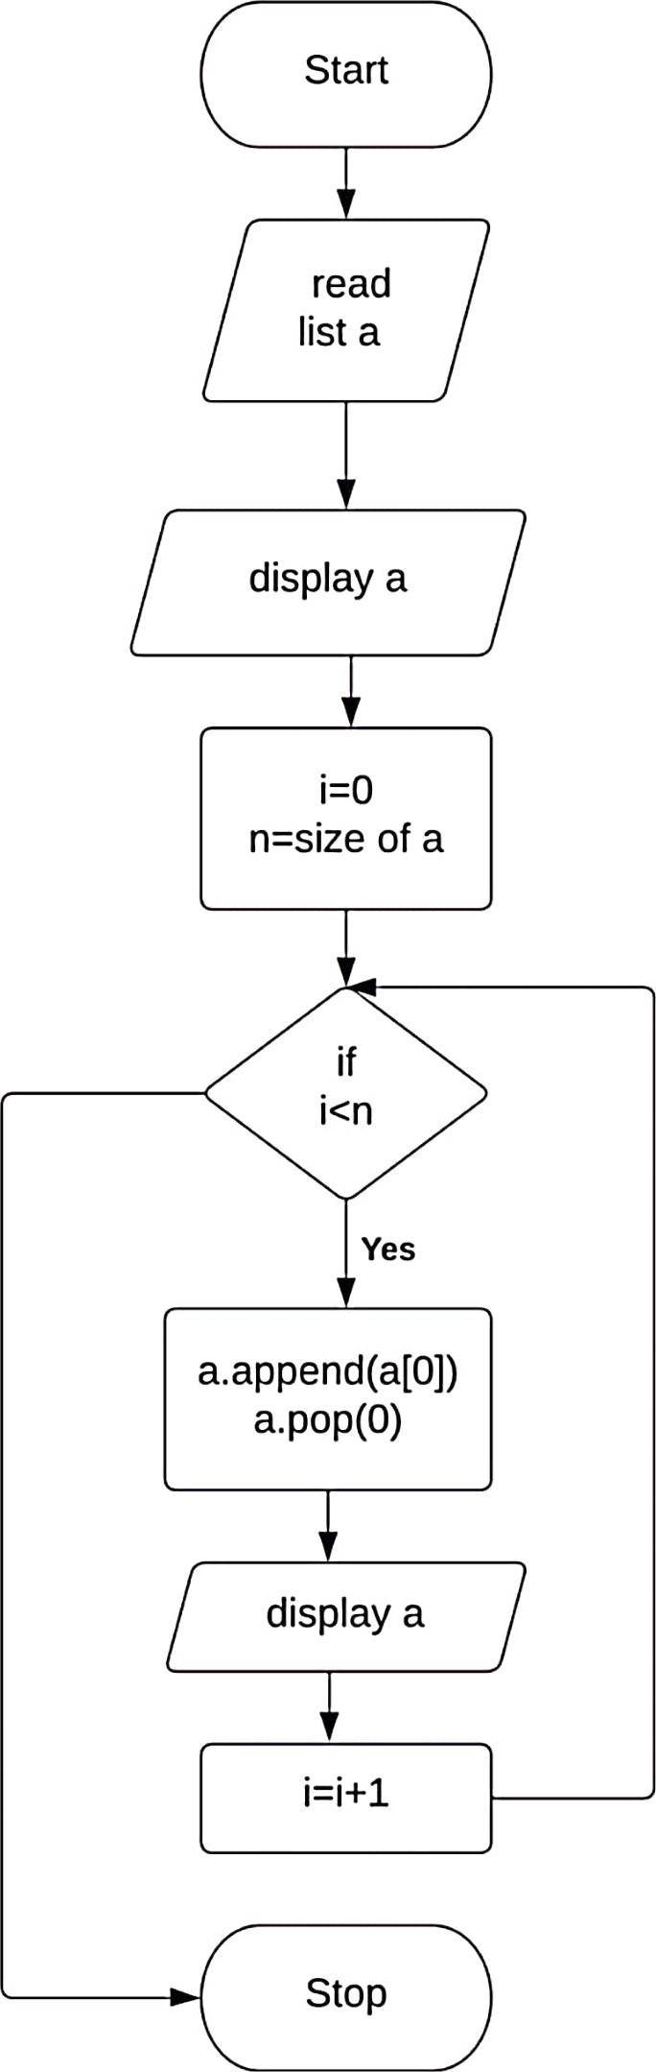

# 2(e) CIRCULATING LIST OF VALUES USING SLICING OPERATOR

## 25-12-2022



draw flowchart and write algorithm, program to circulating the list of values using slicing operator.

Algorithm:

|  |  |
| --- | --- |
| Step 1 | : Start |
| Step 2 | . read list a |
| Step 3 | display a |
| Step 4 | . assign i=O, n=size of a |
| Step 5 | : Check if I < n |
| step 5.1 | : If Yes , then compute cir=a[1:]+[a[O]], i=i+l |
| Step 5.2 | display cir and go to step 5 |
| step 5.3 | • If No, then go to step 6 |
| Step 6 | • Stop |

Program:

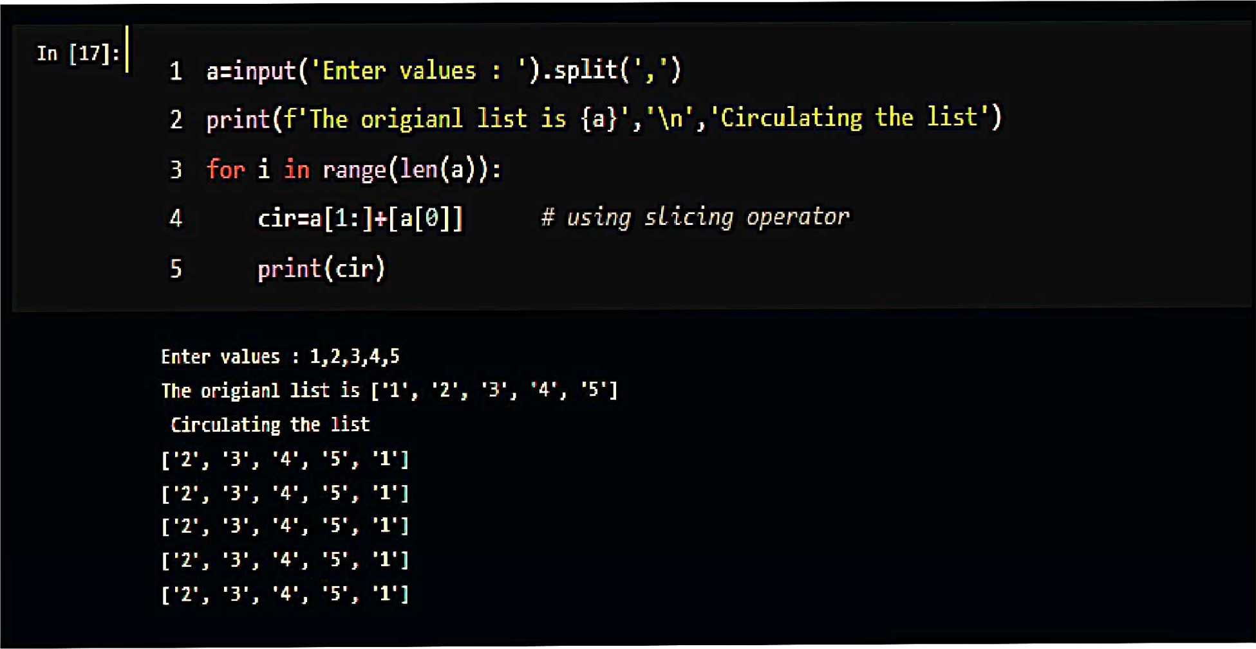

No 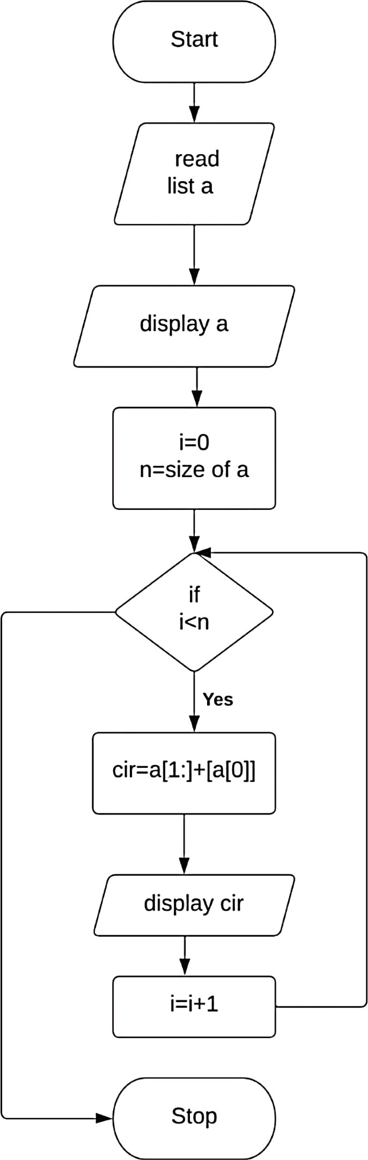



The python program is executed and output is verified successfully.

2(f) CALCULATE DISTANCE BETWEEN TWO POINTS

## 25-12-2022



draw flowchart and write algorithm, program to calculate the distance between

two points.

Algorithm:

|  |  |
| --- | --- |
| Step 1 | • Start |
| Step 2 | read values of xl,x2, yl, Y2 |
| Step 3 | import math |
| Step 4 | . compute d= math.sqrt((x2-x1)**2+(y2-y1)**2) |
| Step 5 | display d |
| Step 6 | • Stop |

Program:

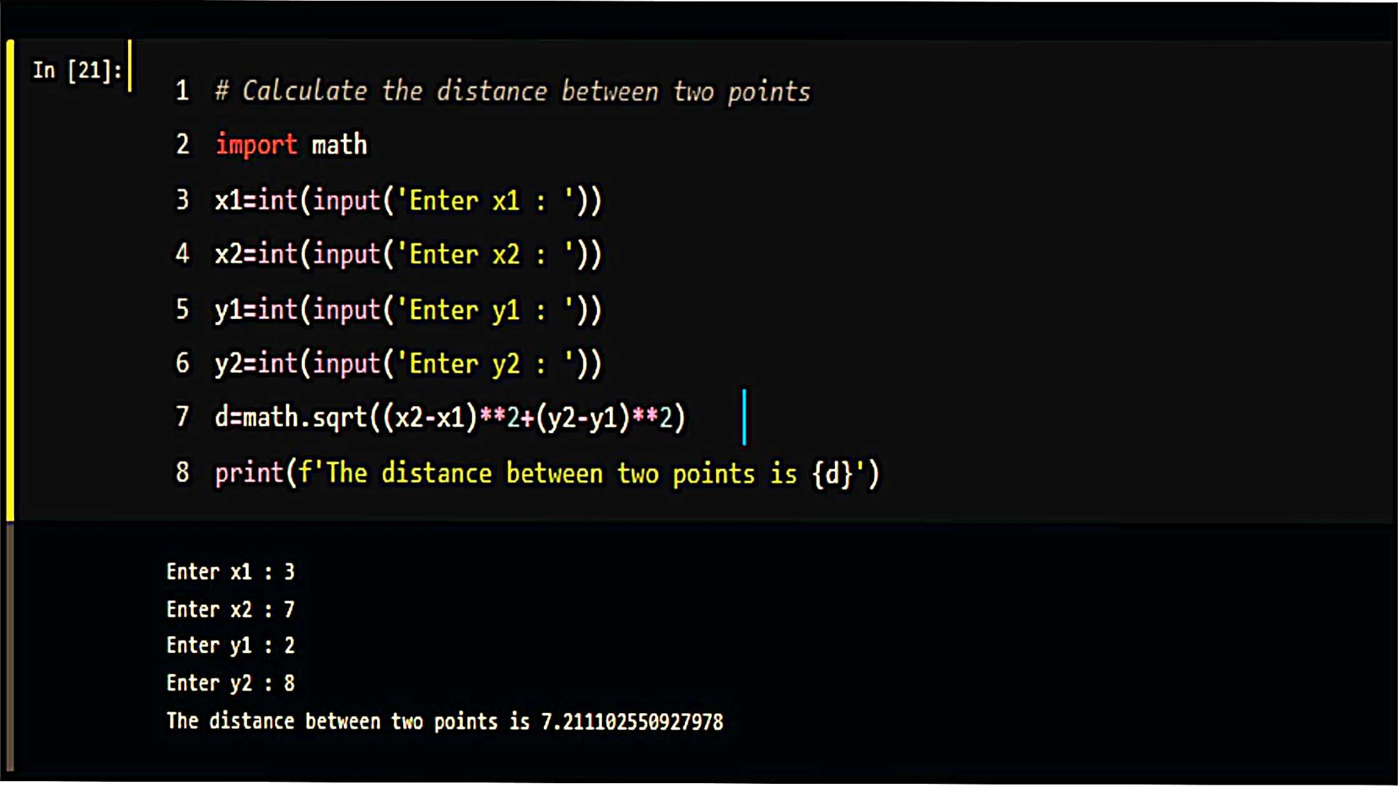



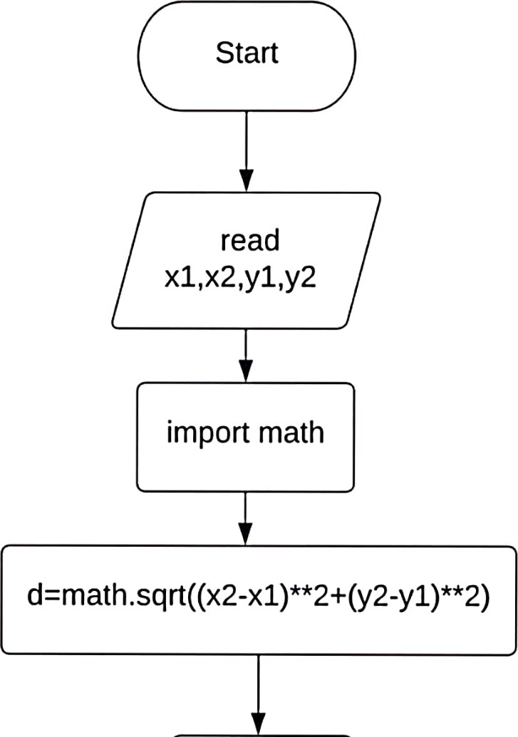

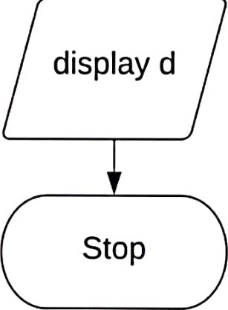



The python program is executed and output is verified successfully.